User documentation – help system

# Description

Workouts are important to oneself when they first start it and requires something to keep track of routines for themselves and for others. We decided to put our main focus on helping the users who uses our app on not only holding and saving routine exercises when they sign up, but also allow them to use a timer when working out to allow them to keep track on how much time they spent on the exercise. With recent studies, we learned that people who work out also want pictures or instructions on how to do a work out properly in case they started doing an exercise incorrectly that can harm their body or not getting the full experience from that exercise. By studying others on what they want in an app helped us create a simple app that is easy to use for beginners to professionals as they are able to access the information they want quicker and less time consuming, and with any improvements the app requires they can just give use a feedback.

# How to use

● Register an account / login user account from Home Page

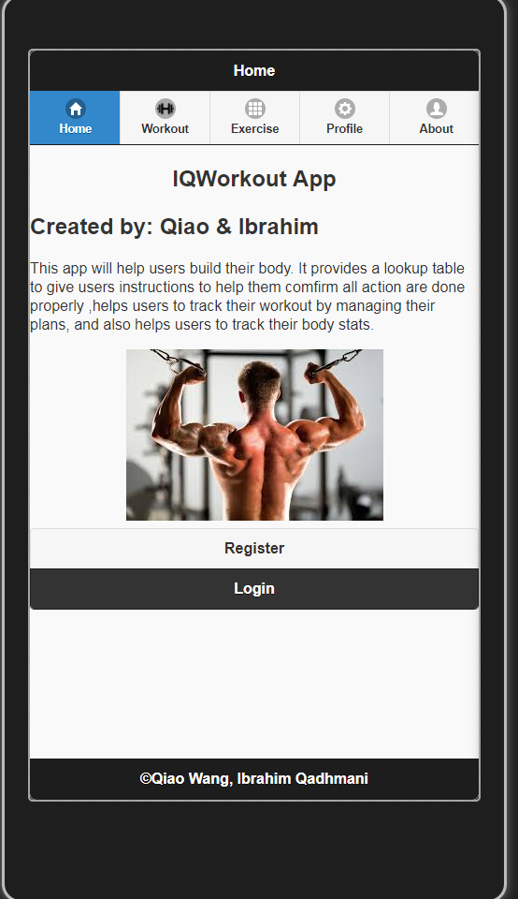

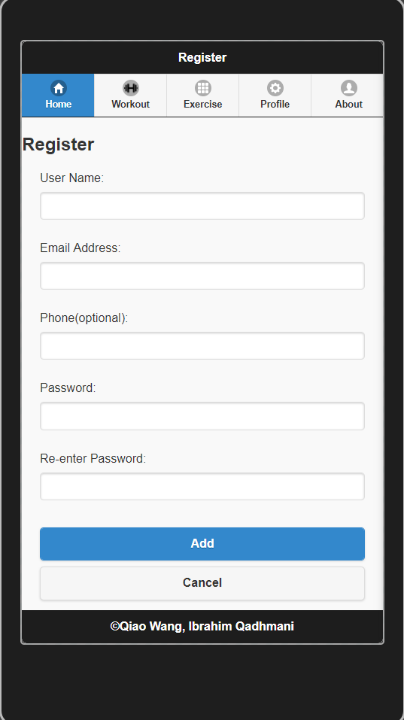

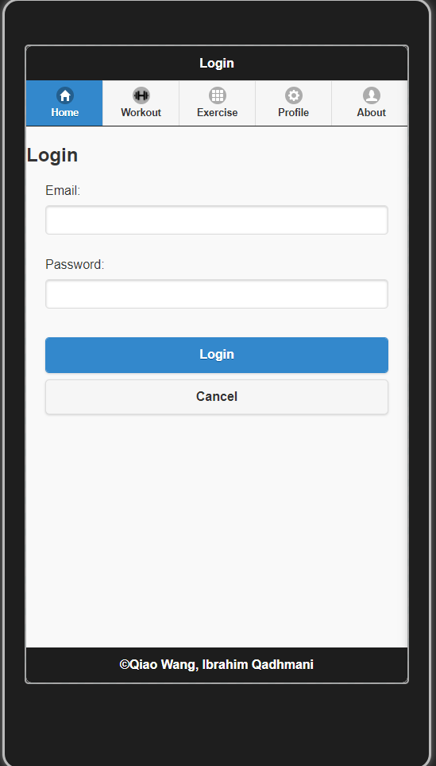

* User can edit or delete profile in profile tab. Also logout.

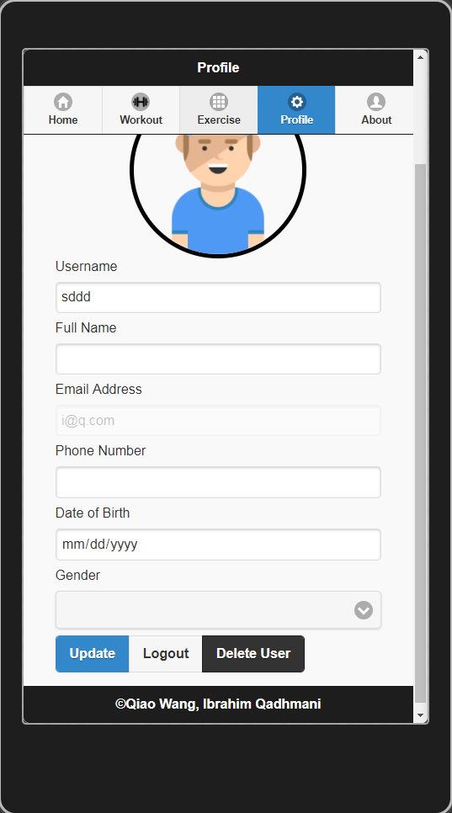

● Open workout tab.

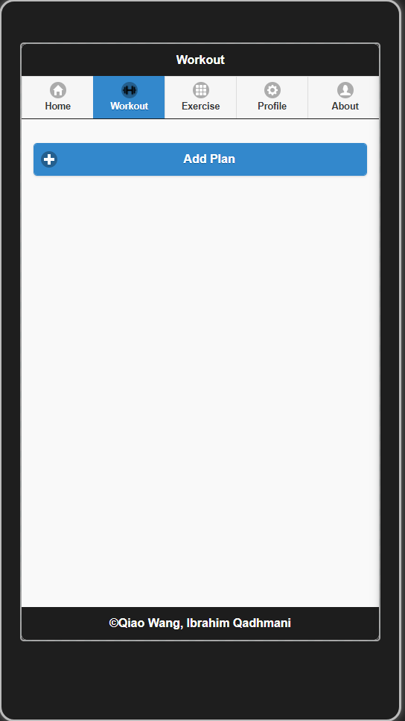

● Create a new plan or more by name and current date.

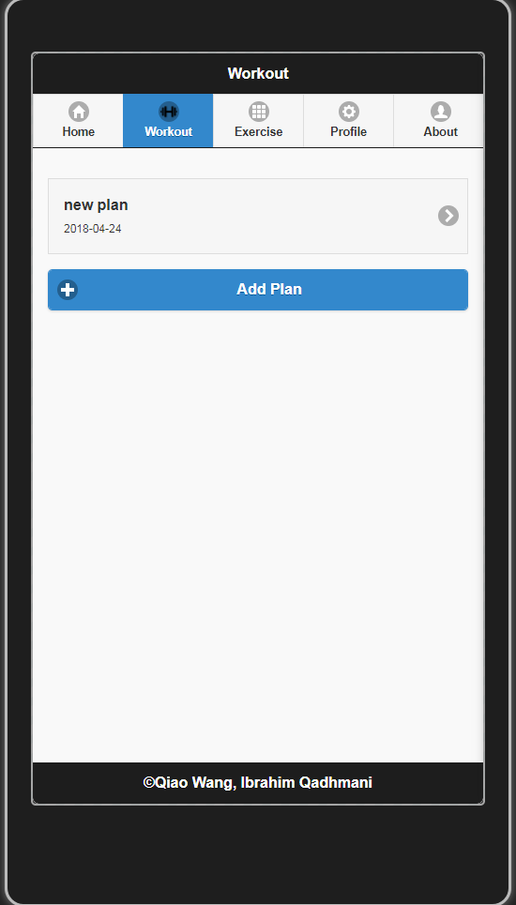

● Click one plan, add actions in current plan.

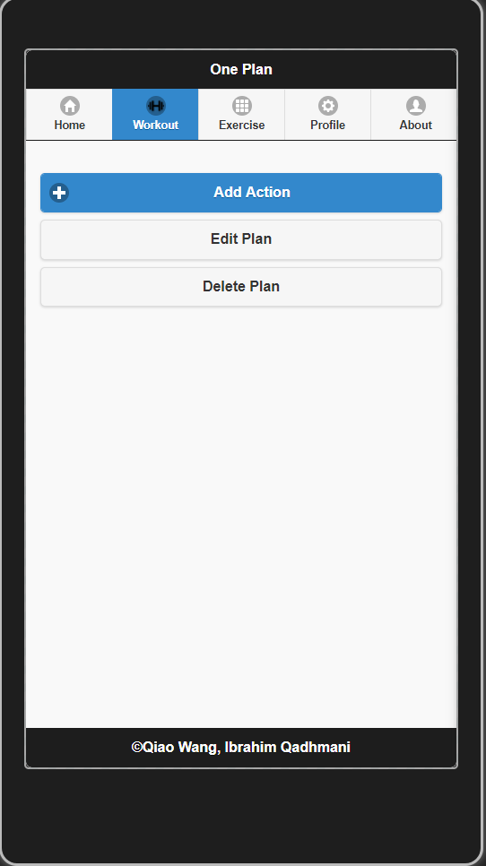

● Show action list

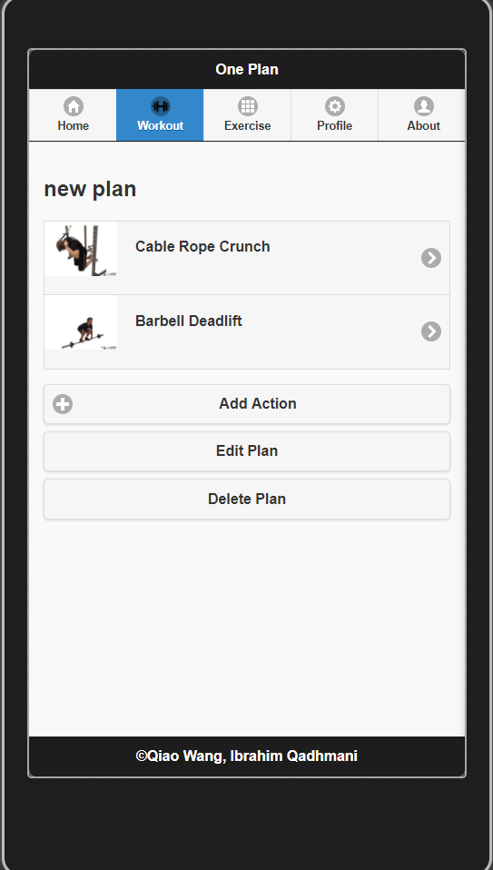

● Click one action, then go action details, enter details each time user finish one set.

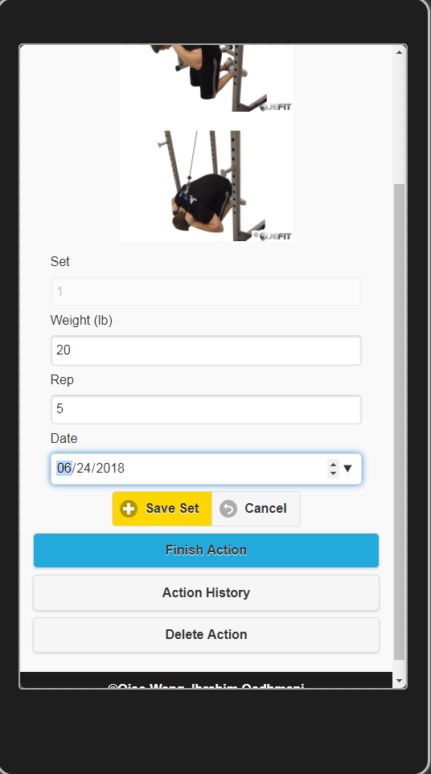

● User can edit plan name, edit action detail

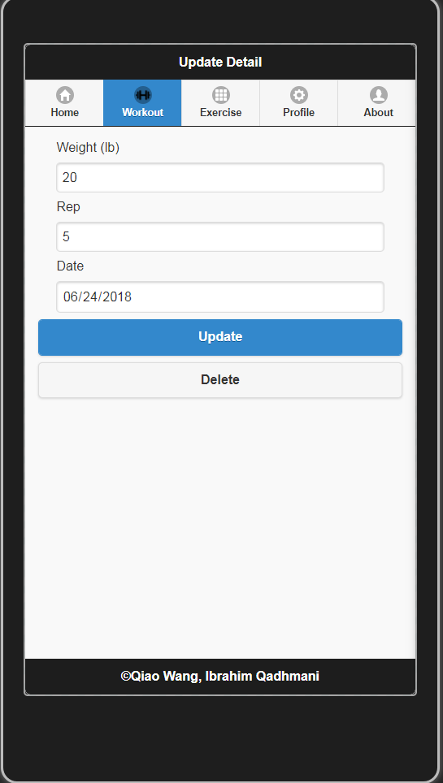

● User can delete plan, action, and detail.

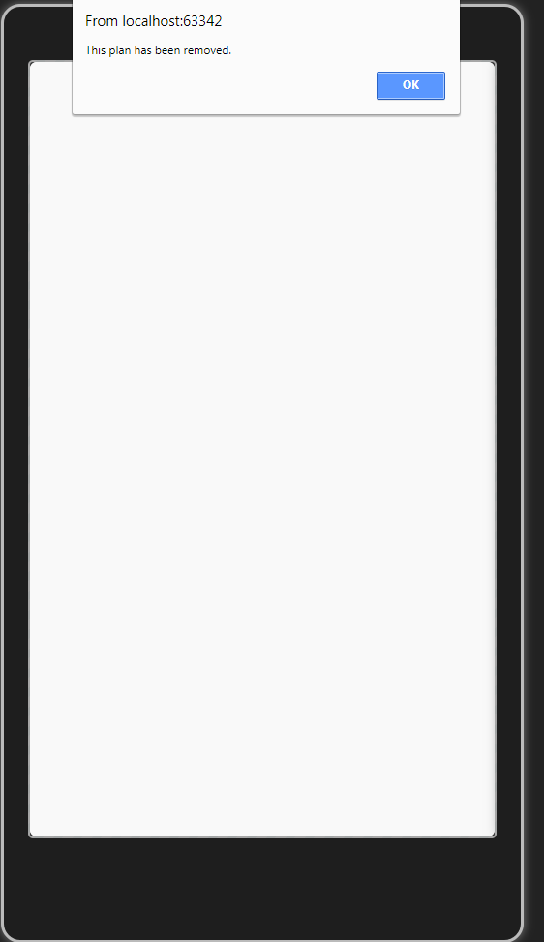

● User can check all actions by click exercise tab

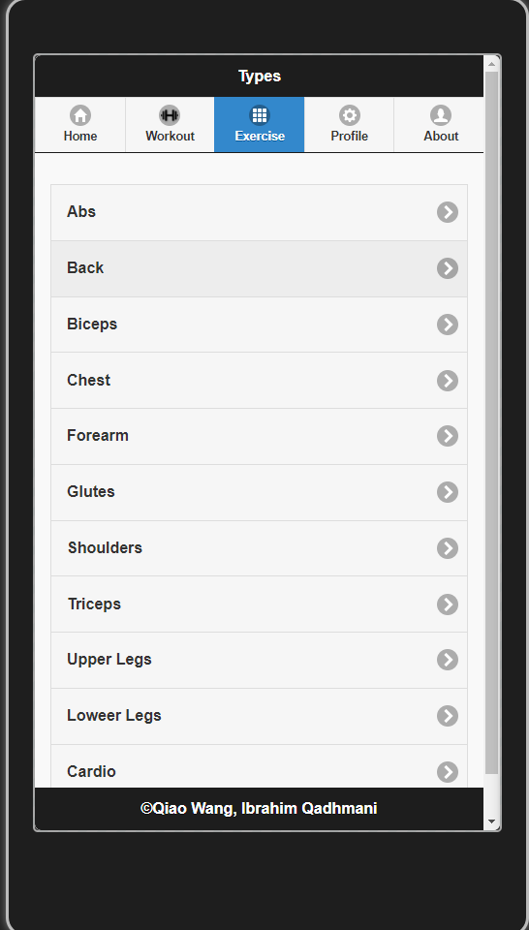

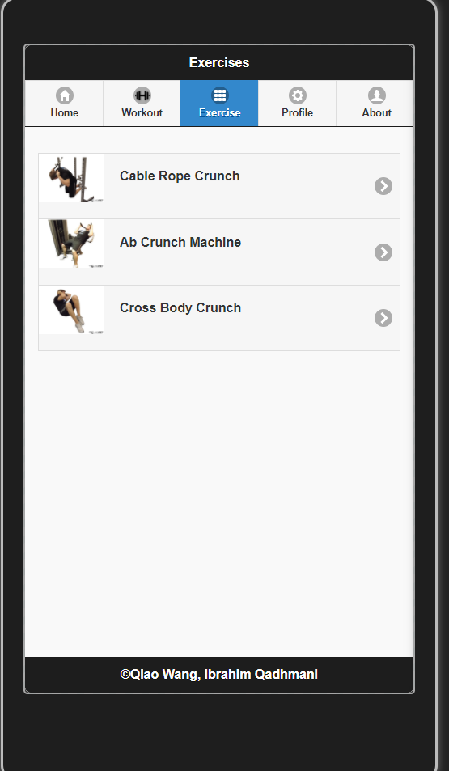

# About the programmers

Ibrahim Qadhmani, 7688823, Iqadhmani8823@conestogac.on.ca

Kevin Wang, 7058308, Qwang8308@conestogac.on.ca